**From:** Blanco, Deana   
**Sent:** Thursday, December 20, 2018 8:37 AM  
**Subject:** ACTION REQUESTED: BioCommunications Process Change for Banner Services

***Sent on behalf of John Scherpf, Chief Operating Officer:***

Thank for your efforts this year to better manage our controllable expenses. Your efforts have led to significant reductions in expenses which can be then steered toward other resources such as equipment, furniture, and staffing. As we roll into 2019, we would like to continue these efforts and expand our scope as we strive to obtain good financial stewardship. We will be implementing a new request process for The University of Arizona Health Sciences BioCommunications starting January 15th . BioCommunications has supplied the hospital excellent services on items such as conference room set up, teleconferencing/streaming, printing, photography, and other valuable services for many years. Many of these services can now be provided by Banner Health and we should utilize our own services whenever possible. We realize there will still be a need for BioCommunications services from the hospital but changes in practices are needed and should include:

* **Conducting meetings that require connection with other Banner facilities in Banner space. BUMCTS can connect with other Banner entities via teleconferencing (Skype) and several conference rooms are equipped for this purpose (Rooms 2406, 2423, 2365, and 4632 are examples). BUMN has some conference rooms available and the new tower will also have several brand new, fully equipped conference rooms. In addition, we will construct 7 new conference rooms in Tower 4 (Bldg. 201) in late 2019, early 2020 that will also have full IT capabilities.**
* **Conducting clinical trainings in Banner space including both campuses.**
* **Projector and phones are available in Hospital Administration at Tucson campus for Skype meetings in current conference rooms that are not equipped.**
* **Printing should be handled by the Banner Print Shop (Prisma) with proper approval for large projects and/or complex projects.**

**ACTION REQUIRED**: Beginning January 15th, BioCommunications requests that are funded by a Banner cost center must be approved by the Administration Team. This includes all new, ongoing and recurring requests. This will not affect services that are charged to the University. Attached you will find a form for all BioCommunications requests, which will also be available via the facility Intranet site. Once the form is filled out email the form to [BioComRequest@bannerhealth.com](mailto:BioComRequest@bannerhealth.com). After the request is reviewed by the Administration Team, it will be sent back to requestor and forwarded to BioCommunications if approved. Please note that requests should be made well in advance of the need and reoccurring requests can be made by noting on a single form. All new and existing requests will need to be made for 2019. ***Please share this information broadly.***

Thank you for your continued leadership and engagement.

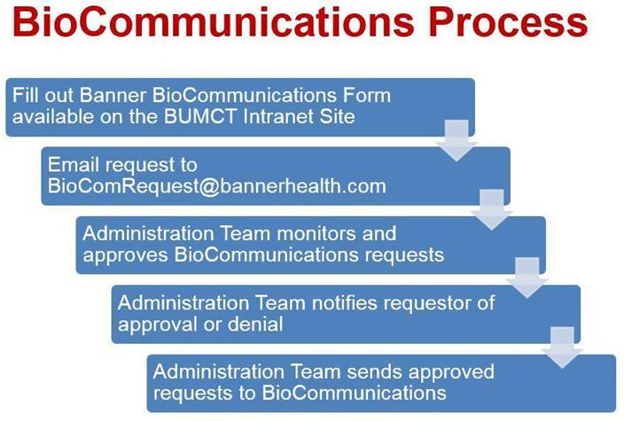

**John W. Scherpf, FACHE**

Chief Operating Officer

Banner University Medical Center

Tucson & South Campuses

520-694-3975 (office)

[John.scherpf@bannerhealth.com](mailto:John.scherpf@bannerhealth.com)

[cid:image002.png@01D4983A.F3B382A0](https://www.bannerhealth.com/services/academic-medicine)  
  
Health care made easier. Life made better